Animating Geospatial Temporal Data to Analyze Movement Through Cities

Ryan Williamson#1, Andrew Harrison#2, Michael Banek#3

*CSE Department, The Ohio State University  
2015 Neil Avenue, Columbus, OH, US*

1williamson.584@osu.edu

2harrison.692@osu.edu

3banek.2@osu.edu

***Abstract—* We proposed to develop an animated visualization of pedestrian movement throughout the city of Columbus. This visualization details pedestrian movement in the city based upon the gps locations of their smart devices throughout the day in an effort to gain insight into the flow of foot and car traffic across time. The insights found by this visualization can enable planning officials, journalists, and companies to understand how to better utilize their existing assets and where to drive investment dollars.**

***Index Terms—*Geospatial, Temporal, Animation, Flow Maps, Vector Fields**

1. **Introduction & Motivation**

It's difficult to understand how people move throughout the day with static images. A picture can tell a thousand words, but sometimes a thousand words is not enough to describe and explain valuable information. City planners need to understand overburdened infrastructure to lessen the load of traffic and make a city more accessible, and store owners need to know where to best locate themselves and advertise their business to maximize profits. These users can struggle to derive useful information from static imageries, so we sought to create an animated visualization of the movement of pedestrians in the city through different forms of transportation.

1. **Design**
2. *Goals:*

Our overall goal was to develop a method to display movement overtime through a city in one visualization. This could be done by creating a easy to use visualization toolbox web application. This visualization toolbox would be a interactive animation that gives the user the ability to perform many different features. These users would be able to understand how residents and customers are moving throughout a city, as well as give an insight to the flow of people and traffic throughout a city. This visualization would perform scrubbing to show specific times and is a solution that could be generalized to any geospatial temporal data. This goal set the framework with which we approached the development of our visualization.

1. *Data Abstraction*

Our data is a collection of smart device users’ locations throughout a 24 hour period in Columbus, Ohio. Each data point contains a users latitude, longitude, a timestamp, and a unique user id. Alone, this data provides a vague idea of what locations are most populated in the city.

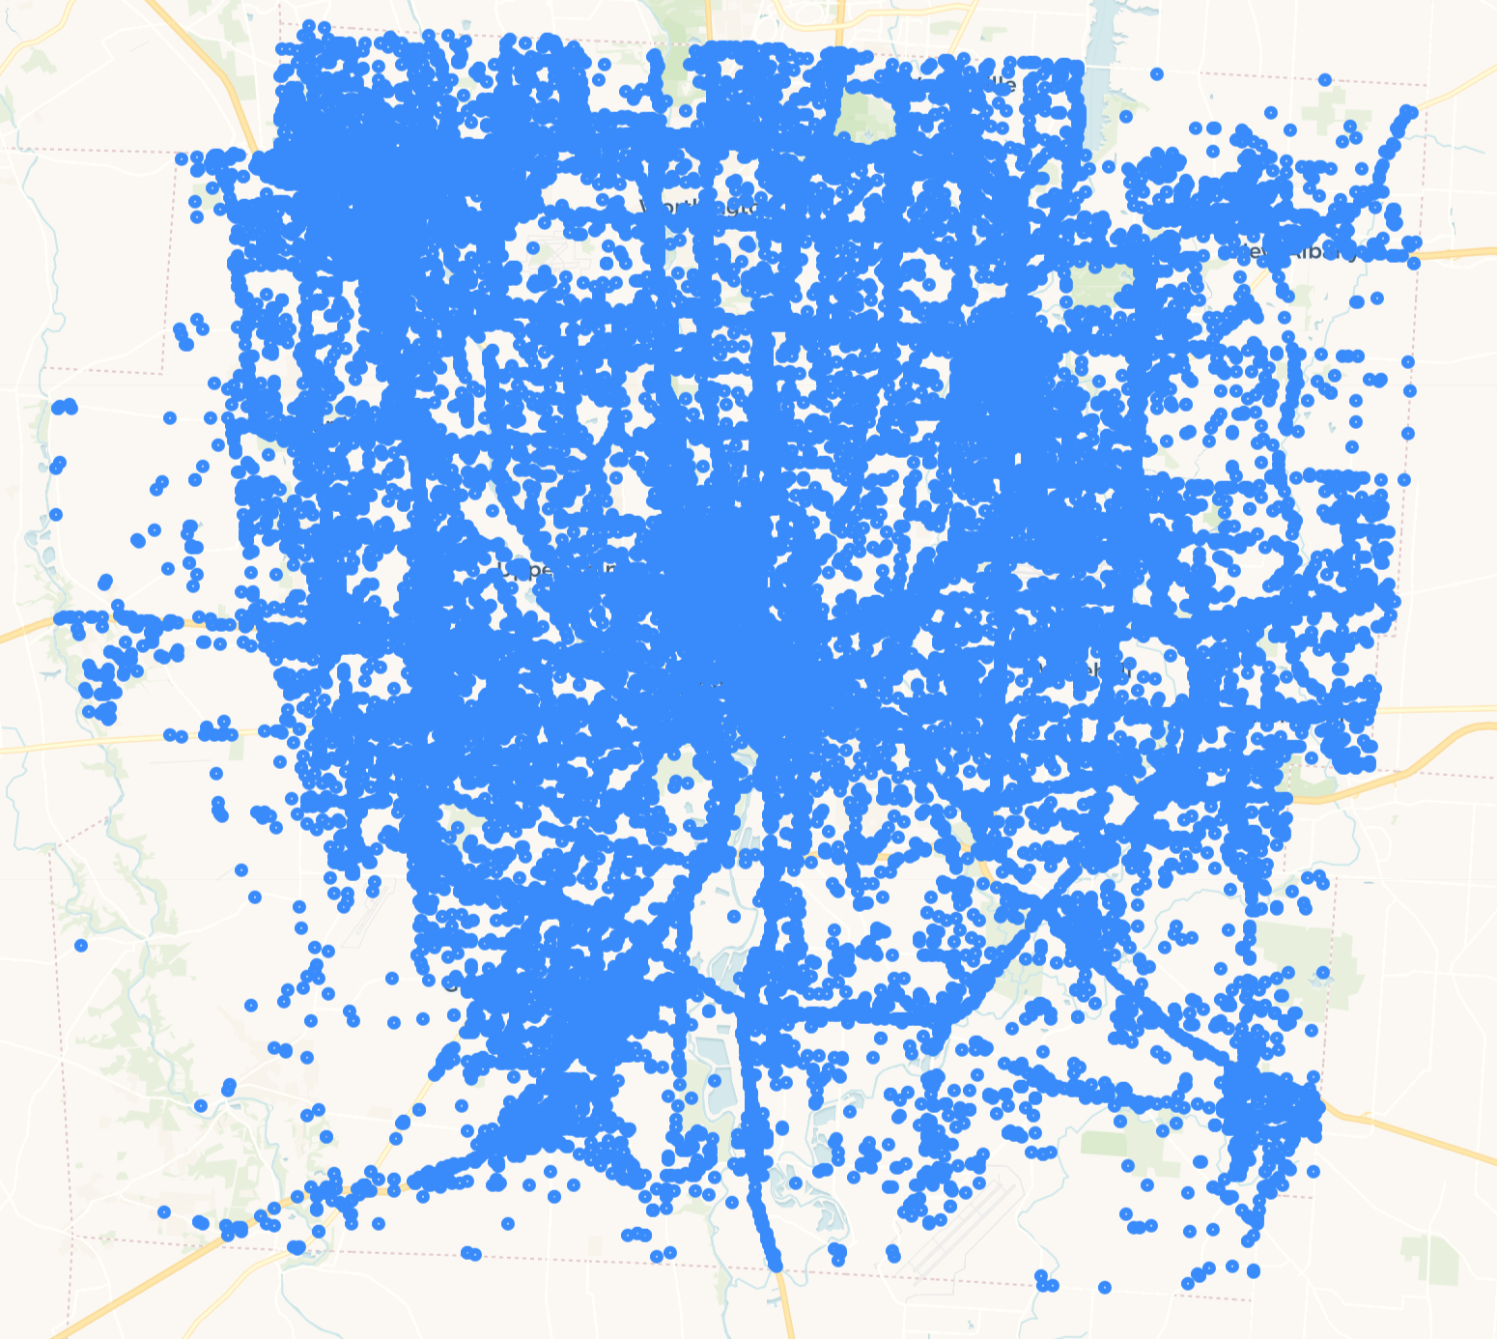

*Figure 1. Map of the city of Columbus, with each of the recorded data points. Each data point is colored blue, and is obviously fairly hard to distinguish from a nearby point. This is the raw data that was used to create the visualization toolbox.*

As you can see in Figure 1, this data serves our purposes well to locate high activity areas, but it didn’t provide many insights into how the road network was being used.

To get more insight into how people were actively traveling in the city, we wanted to create a calculation to view a user’s ‘journey’ as they moved from one location to another. We achieved this by tracking a user id over time, which provided us with the information visualized in Figure 2.

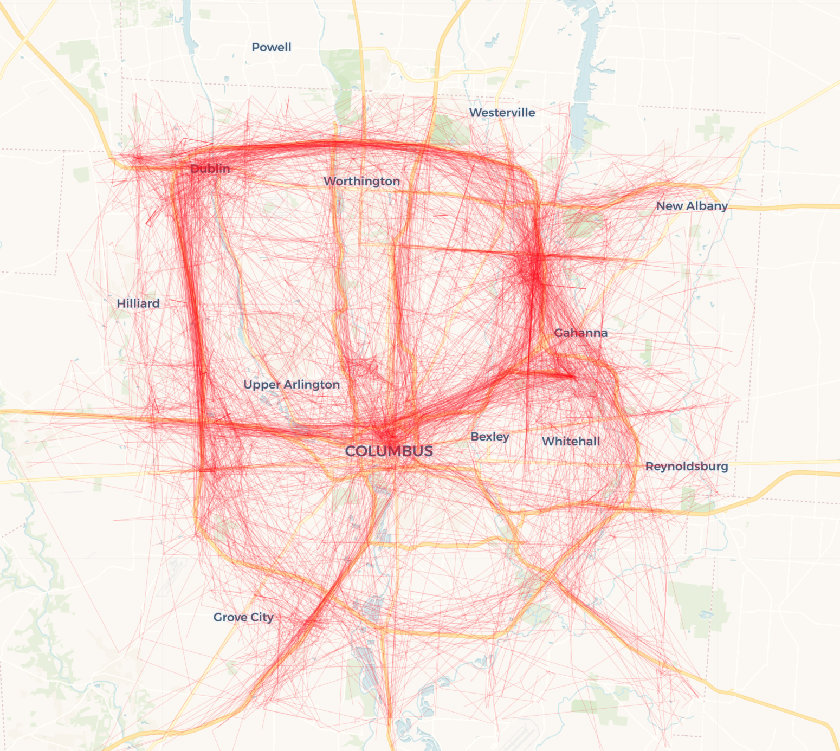

*Figure 2. Map of the city of Columbus, showing the paths of pedestrians from within a selected time. Red is used to represent the paths of users. When the visualization is loaded and ran, each path starts out as a point, and “travels” along the map to the final destination.*

Transforming the data into journeys as such provided many more insights that simple points were not able to. We can actively see which sections of the road network are being used, how long users are traveling, and locate frequent beginning and end points.

*C. Task Abstraction:*

The primary tasks we set out to complete were:

1. *Identify hotspots of pedestrian traffic*

We wanted to identify which areas are being used the most every day. This insight could be most useful to city planners, as they consider which sections of the road network may need to be closely monitored for overuse.

We completed this task by designing a heatmap of user locations throughout the day. You can see this in Figure 3 below.

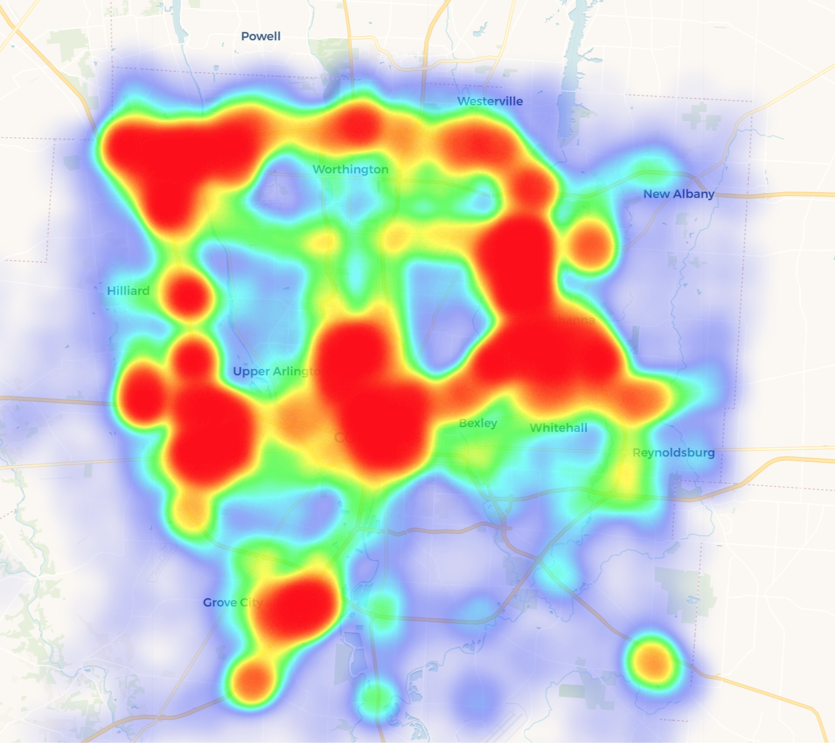

*Figure 3. Heat map of the city of Columbus, showing the volume of people in a location at a set time. As seen, the highways, and center of the city are shown to have a large volume.*

1. *Display how these hotspots change and shift throughout the day*

The overall heat map provided a good overview of which areas were being used heavily, but we were also interested in seeing how this changes over the course of the day. This insight could be useful for police to decide which locations they should be located in throughout the day.

We completed this task by enabling the ability to scrub through time to see the heatmap change throughout the day. You can see in Figure 4 that certain areas are used more heavily at certain points in the day.

1. *Identify where people are travelling and how they are utilizing the road network on their journeys*

We also wanted to have a visual way to see where people were coming from and where they were moving to. This insight could also be useful to city planners, as they consider which roadways may need more or less lanes.

You can see the overview for this in Figure 2. From this visualization we can tell that 670 around the airport and 270 around Dublin are seeing the heaviest use.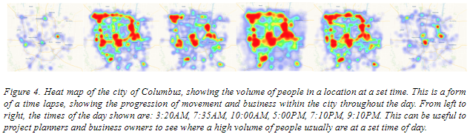

We also wanted this to be more interactive, so we made it possible to select a specific region to use as a starting point for journeys. In Figure 6 you can see our solution for this. Selecting any hexagon will show journeys that originated within that area, effectively allowing the user to discover the main pathways that are being used to exit a certain area.

We also wanted to make this functionality possible for a larger or less geometric area. In Figure 7 you can see how we enabled the user to draw their own selection area. This is useful for users that may be interested in looking at the journeys within their township.

1. *Break out the locations of high car, bike, or walking activity*

We were also interested in identifying the methods of travel that people were using within specific areas. This insight could be useful to city planners to decide which areas may need more walking or bike paths.

We completed this task by overlaying the map of Columbus, Ohio with a hexgrid. You can see in Figure 5 that each hex is filled with color proportionally based upon modes of transportation. With this hex map, we can easily identify that the Ohio State campus area and the city of Dublin have a large proportion of pedestrians on foot.

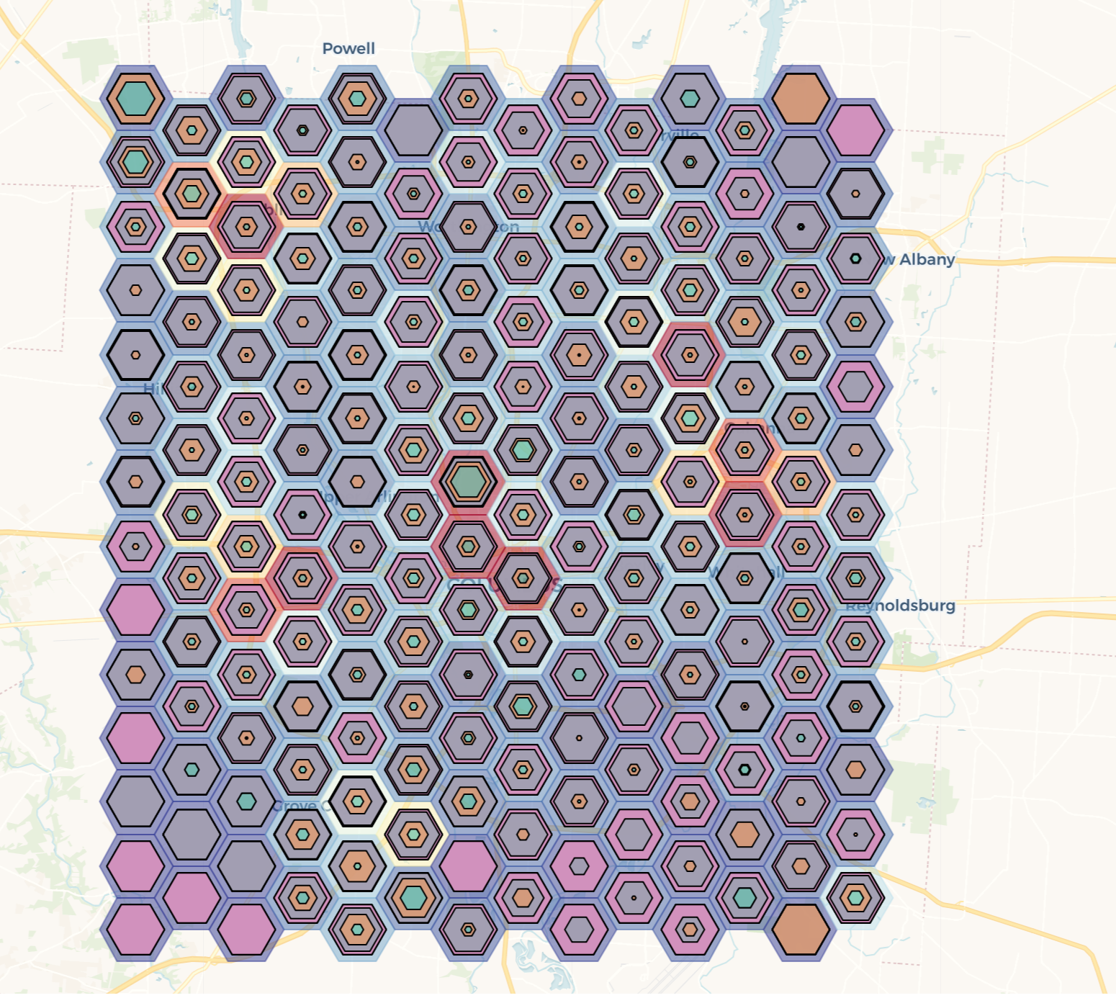

*Figure 5. Hex map of Columbus, Ohio displaying breakout of methods of transportation. Green - walking, Orange - biking, Purple - driving < 30 mph, Pink - driving > 30 mph*

*D. Design Considerations:*

Design wise, the group had to consider many different aspects of this visualization. First, the coloring was something that needed to be taken into consideration. We decided to use for the heatmap the standard, widely used format of coloring of blue-red to show the density of people in a set area at a specific time, based on their smart device location. To track users paths, we decided to bin areas into hexagons all over the city. Hexagons are consid the best to use on maps that include aspects of movement paths, and also bins the data well. Any point that is within the hexagon is closest to the centroid of so than any neighboring hexagon [6]. The group also had to choose the colors of specific paths when selected for selection of an area, and from a hex, in which green was chosen for routes inside a hexagon, and red for selection within in area. Green was chosen inside a hexagon for two reasons: 1) Green is a color that human’s eyes are sensitive to, and 2) some of the hexagons with high volume of people are already red, so it would cause a lack of clarity of where the trips origin was This is shown in figure 6. The color red was chosen within a selection since it would not interfere with the color blue inside the selection, and be easily seen by the user, as shown in figure 6.

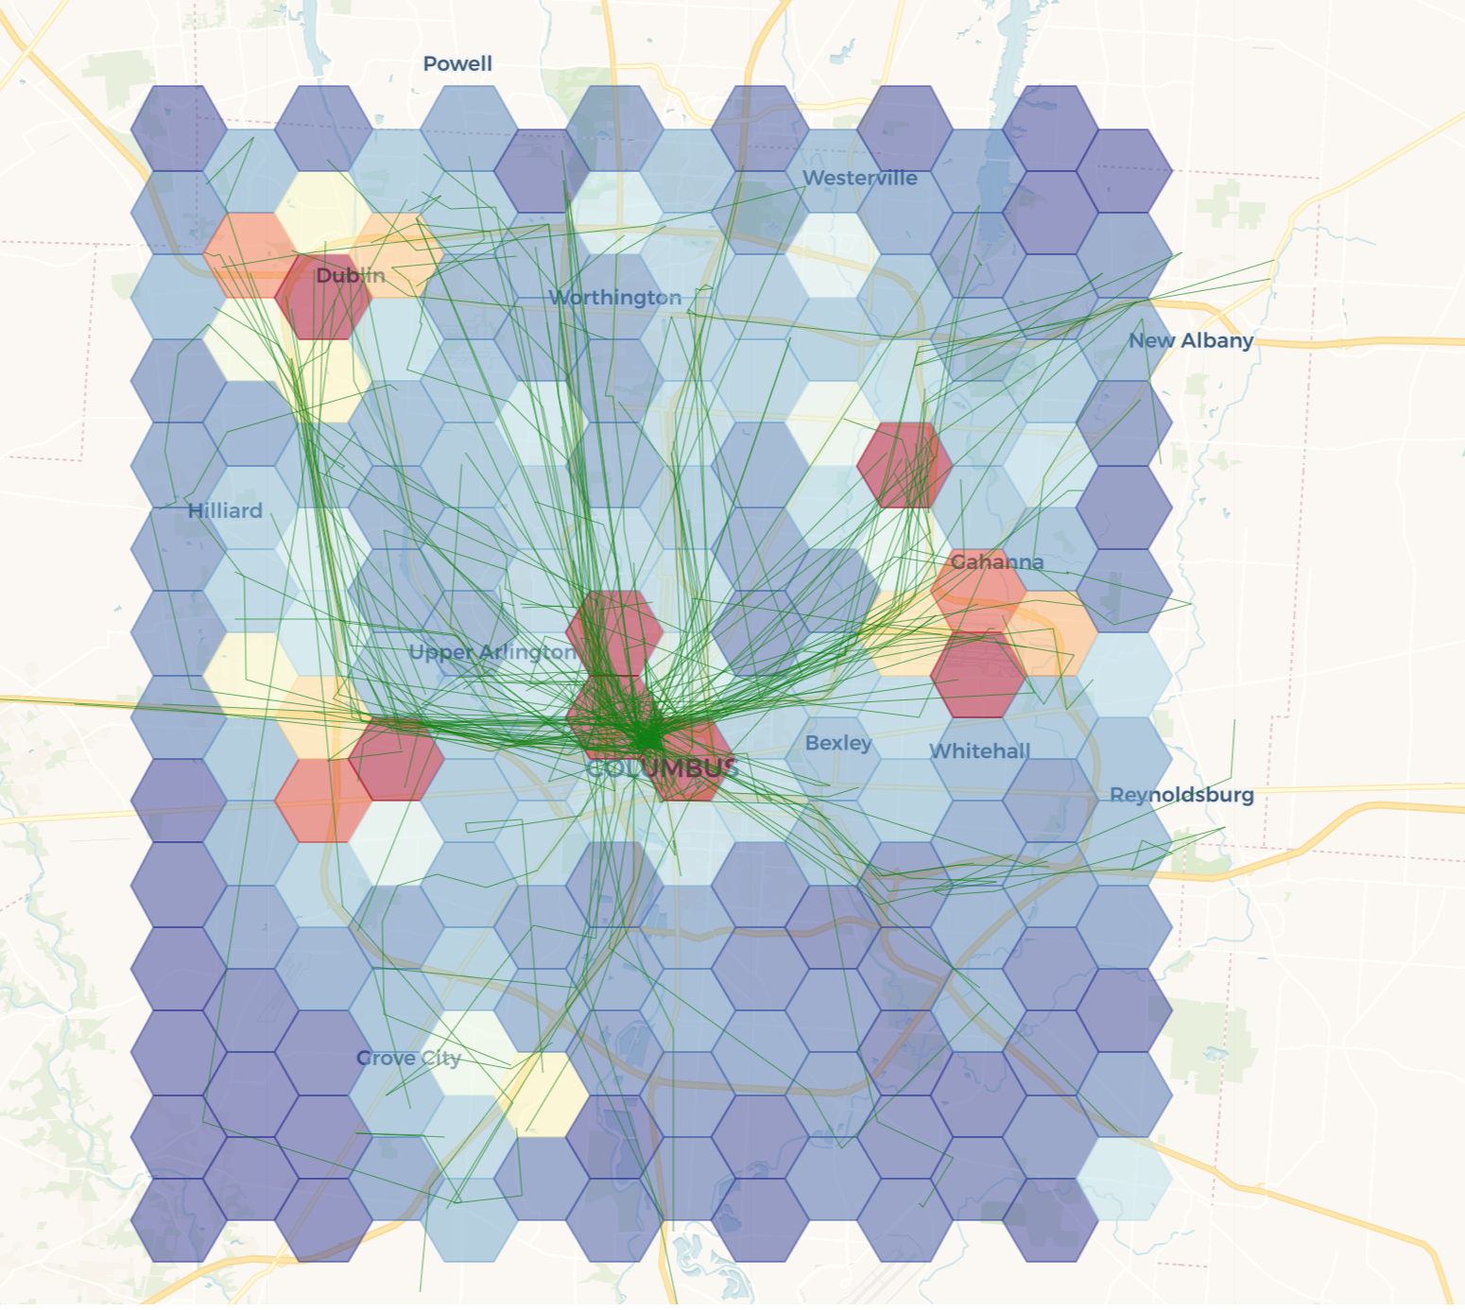

*Figure 6. Hex map of the city of Columbus, showing the paths of pedestrians from near the middle of the city. The hexagon color shows where the most people are at a set time.*

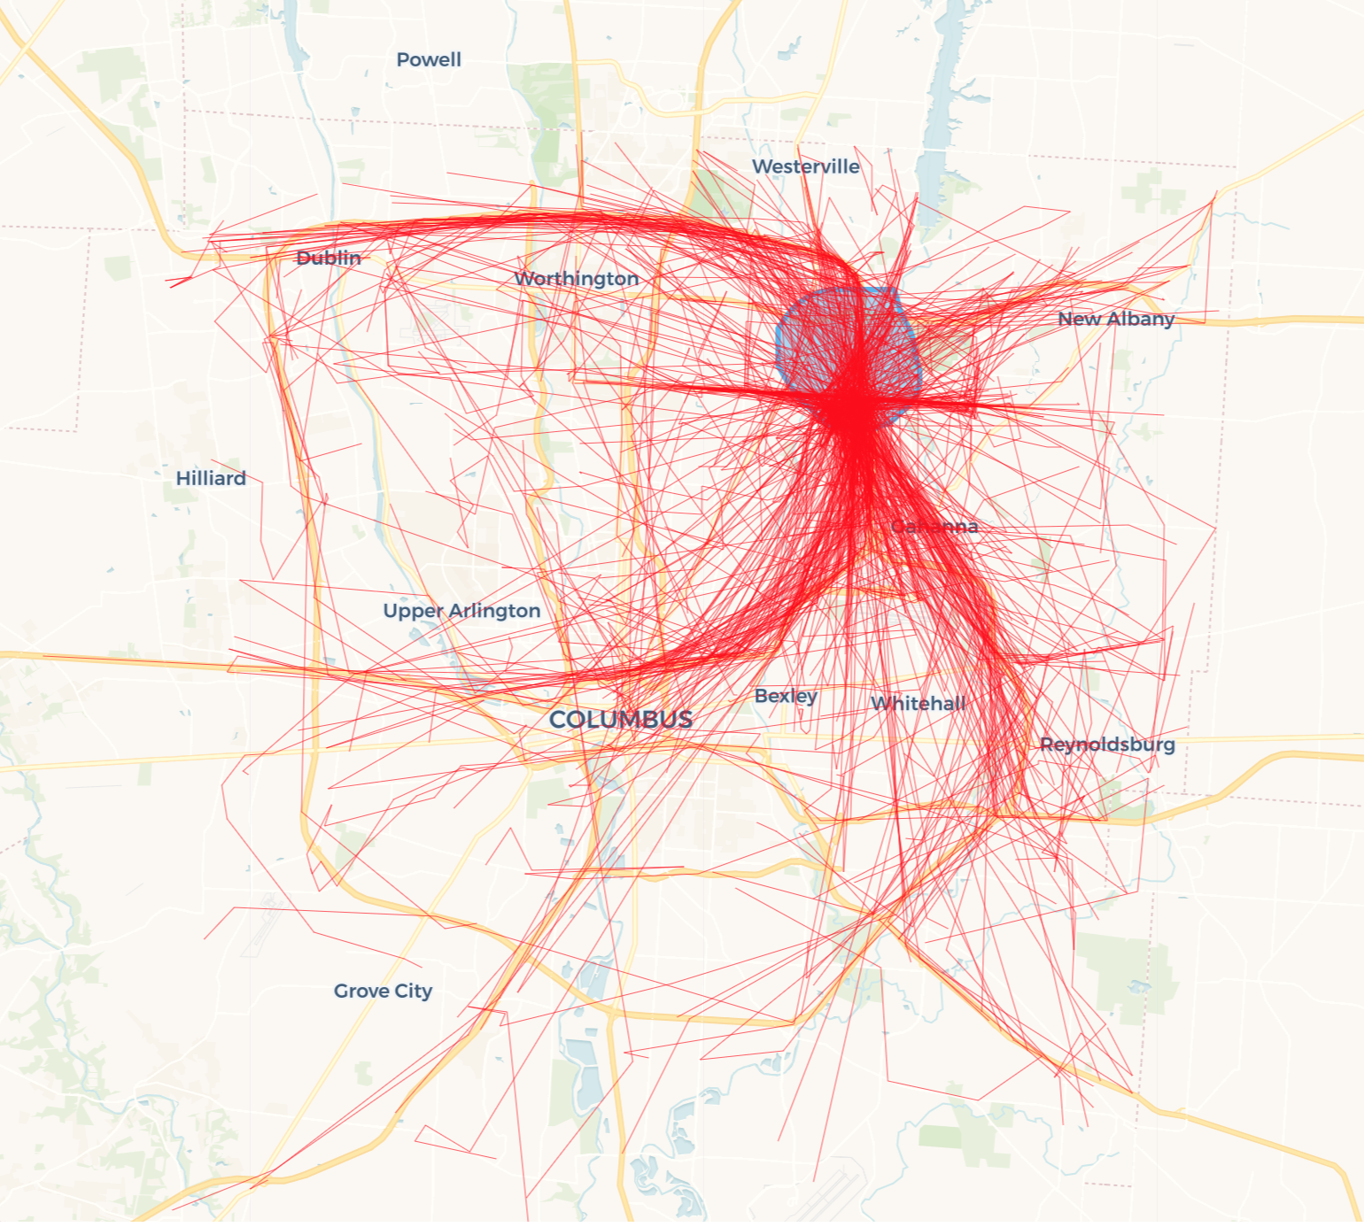

*Figure 7. Map of the city of Columbus, showing the paths of pedestrians from within the selected area (highlighted in blue). Red is used to represent the paths of users in which their path of travel originated from within the selected area at one set point in time.*

*E. Projected timeline:*

Our timeline for this project was thorough, and well-spaced out for us to focus on one task at a time without any other distractions within the project. For weeks 1 and 2, the group focused on data collection, data cleaning, and a literature review. Weeks 3 and 4 were designated for prototyping, and importing the data into the backend. Weeks 5 and 6 were designated to refinements, user testing, and user feedback. The final week was designated to presentation creation, the final visualization, and effectiveness analysis.

**III. Implementation Methods**

In order to accomplish our aforementioned goals, we utilized a variety of tools to reduce the amount of effort necessary to complete this project. The tools are broken into two types: backend and front end. The backend exists to serve the data and the front end as the visualization platform.

*A. Backend:*

On the backend we utilized the Heroku API [1] for data aggregation, and a MongoDB [2] implementation for data storage and manipulation. MongoDB is a document-based database which allows for easy importing of the derived journey datasets. Furthermore, its automatic integration with the Heroku API makes it easy to pull the data from the backend and analyse it. The API serves primarily as a place to serve cleansed data sets that have already been post processed in order reduce the computational workload on the front end. Minimal development effort was spent setting up the API as it does not support querying, instead acting as a cloud based data store.

*B. Frontend:*

On the frontend we have a variety of tools that are being used. The main ones being used for this visualization are Angular [3], D3.js [4], and Leaflet [5]. Angular exists mainly as a web application wrapper to enable easy connection to the Heroku API and integration with D3 and Leaflet. Leaflet is used as the mapping engine; its rich library of plugins make it easy to rapidly prototype. D3 enables special visualizations that are not otherwise possible. Specifically, the animations and variety of flow maps/vector fields. Turf.js was used to perform any geospatial queries/analysis. Four leaflet libraries were used: L.heatlayer to generate the heatmaps, L.PolySnakeAnim to animate the rendering of the journeys, Leaflet-dvf was used to generate the hex area charts, and Leaflet.Freedraw to draw the geo scoped queries.

**IV. Analysis**

Our evaluation criteria was broken down into two parts: how effective is the User Interface, and do city planners find the visualizations useful when trying to understand movement. We met with the City of Dublin, and a transportation industry professional from Teradata when evaluating the product. The overall feedback was extremely positive from both parties. They found the ability to geoscope queries and also see at a high level the distribution of journeys particularly valuable. The City of Dublin appreciated the insights from the initial version of the application, as it helped demonstrate to them the use of their bike path network. The professional from Teradata echoed a lot of the feedback that the City of Dublin had, but had some more constructive feedback. Specifically, after meeting with the professional from Teradata, we added the ability to hover over the hexagonal map and see the distribution of trips. He appreciated the overall distribution chart seen in Figure 5, but found it to be visually cluttered. We also met with Dr. Chen and Robert Gross during the prototype phase. Their feedback was instrumental in honing the direction of the product. Following our discussion, we added the hexagonal trip distribution charts, more interactivity, and changed the colormaps to be more visually distinguishable.

**V. Outcomes & Impact**

Our overall product is an easy to use geospatial temporal analysis web application. The application enables business owners, city planners, and analysts to understand how residents and customers are moving on a given day. This can improve their understanding of the flow of people through cities and can help them make more educated decisions. It achieves this by animating journeys (Origin Destination pairs with route data and accompanying speed) over a region’s map. The journeys in combination with flow maps and vector fields highlight how people are moving on both a macroscopic and microscopic level.

**VI. Conclusions:**

*A. Summary:*

The group was able to create a visualization toolbox that displays the movement over time of pedestrians throughout a city. There are many different tools for users to use to see movement at specific times, specific areas, and types of transportation used. This toolbox can be used for any city, and can give insight to users, as was stated in our goals for this visualization. It can be used by many different users for many different purposes, which is a very intriguing and exciting realization of the group’s work. This should help business owners figure out where to advertise themselves the most, and what would be the most effective place to do so. This will also show city designers and planners where the most traffic is within the city, and where further improvements, or creation of infrastructure could be. This can also be used by the common person who is just interested in seeing what areas to avoid during rush hour, or what areas to venture into during the nighttime.

*B. Future Work*

Overall, our group did well to utilize our data to its full extent. In the future however, the toolbox could be updated to have working integration with other datasets. For example, integration of COTA public transit data could provide insights into how well these transit services are fulfilling the needs of commuters. This information could be incredibly useful to COTA officials, as they manage their current routes and plan future ones. Our toolbox works well as a platform for visual data analysis, so it could be extended to work for other major cities as well. All of the same functionality that we provided for visualizing Columbus, Ohio citizens could be offered to visualizing similar data in other cities. With enough data, we could effectively compare and contrast cities to evaluate how effective their transportation networks are for moving people throughout their city.

Acknowledgements

The authors wish to thank Dr. Jian Chen and Robert Gross for the assistance in creating the concept, designing the visualization, and evaluating the effectiveness.

References

1. https://www.heroku.com/
2. https://www.mongodb.com/
3. https://angular.io/
4. https://d3js.org/
5. https://leafletjs.com/
6. <https://pro.arcgis.com/en/pro-app/tool-reference/spatial-statistics/h-whyhexagons.htm>